Vortex Mixer—MIX2000
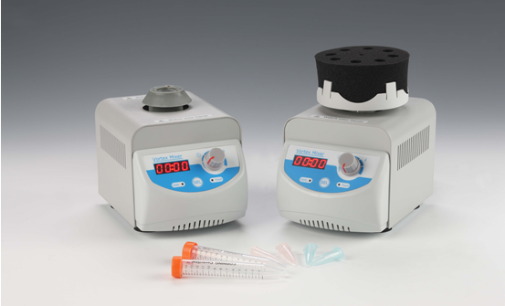
Description:
MIX2000 Vortex Mixer is a high efficiency benchtop mixer. It is used for mixing samples like tissues, cells, bacteria liquid and chemical reagents in life science, physical and chemical analysis fields. It is designed to meet most of the requirements of many lab users.

Features:
- Touch operation or continuous mode.
- Variable speed control from 0 to 2800rpm.
- Used for various mixing application with optional adaptors.
- Accept a variety of test tubes, including the tubes up to 50ml.

Parameters:
Model | MIX2000
Time range | 0sec ~99min59sec/∞
Speed range | 0~2800rpm
Speed control mode | Stepless speed regulation
Run mode | Touch operation/Continuous
Mixing motion | Orbital
Orbit | 3mm
Motor type | Shaded pole motor
Power supply | 60W
Voltage | AC220V/50-60Hz
Dimension(mm) | 197x135x156mm
Weight | 3.4kg

Adaptors
Name | Description | Remark
Single-tube head | For one tube | Standard
Foam block platform | Used with foam block | Standard
Foam block A | 4x29mm | Standard
Foam block B | 8x15mm | Standard
Foam block C | 24x10mm | Standard
Foam block D | 37x8mm | Standard

Note: Foam block platform and foam blocks are only suitable for multiple samples in touch mode mixing.

